Télesphore Evariste Larba KABORÉ | Capstone Project Final Report
From Service Coverage to Mortality Reduction: Predictive and Spatial Analysis of Maternal Health in Malawi
DATA 205 | CRN: 3206
Abstract
This capstone project examines trends, disparities, predictors, and spatial patterns of maternal health service utilization in Malawi using the 2015–16 and 2024 Malawi Demographic and Health Surveys (DHS), complemented by World Development Indicators (WDI) data. The analysis focuses on three key maternal health indicators: antenatal care attendance of four or more visits (ANC4+), skilled birth attendance (SBA), and postnatal care (PNC). Using R, Python, spatial mapping, and Power BI, the project combines weighted descriptive statistics, equity analysis, predictive modeling, and district-level spatial visualization.
Findings show mixed progress between 2015 and 2024. ANC4+ coverage improved from approximately 51.0% to 63.1%, while PNC remained consistently high at about 99%. However, SBA declined from approximately 49.7% to 33.0%, suggesting a major gap in the maternal care continuum. Equity analyses showed persistent disparities by wealth, education, and residence. Predictive modeling using balanced logistic regression demonstrated moderate ability to identify women at risk of SBA non-use but limited ability to precisely predict ANC4+ utilization. Spatial analysis revealed uneven district-level changes, with some northern and eastern districts improving while several central and southern districts experienced stagnation or decline. Overall, the project highlights the importance of combining descriptive, predictive, and spatial methods to support geographically targeted and equity-focused maternal health planning.
Introduction
Maternal health remains a major global public health priority, especially in low- and middle-income countries where preventable maternal deaths continue to occur despite improvements in service availability. Malawi has made progress in reducing maternal mortality over time, but national-level gains may conceal important differences across districts, wealth groups, education levels, and places of residence.
This project builds on prior professional and doctoral work focused on maternal and child health service uptake in Malawi. The central question guiding the analysis is whether improvements in maternal health service coverage are consistent, equitable, and geographically distributed in ways that can support reductions in maternal mortality risk. The project therefore moves beyond simple national averages by combining survey-weighted analysis, predictive modeling, and spatial visualization.
The project addresses the following questions:
- How did ANC4+, SBA, and PNC coverage change between DHS 2015–16 and DHS 2024?
- How do maternal health indicators vary by wealth, education, and residence?
- Which factors predict non-utilization of maternal health services?
- Which districts show the greatest improvements or decline in maternal health coverage?
- How can dashboard storytelling support maternal health planning and decision-making?
Data Sources and Preparation
The analysis uses three main data sources. The first two are the Malawi DHS 2015–16 and Malawi DHS 2024 datasets, which provide nationally representative household survey data on maternal health service utilization, socioeconomic characteristics, and demographic factors. The third dataset is the World Bank World Development Indicators, used to provide national-level context on maternal mortality and broader development trends.
The DHS individual recode files were used for the main maternal health analysis. DHS sampling weights were applied by dividing the DHS weight variable by 1,000,000 to generate representative estimates. Key variables were harmonized across survey years, including district names, wealth quintile, education level, urban/rural residence, age, parity, ANC visits, delivery assistance, and postnatal care.
Three binary outcome variables were created:
- ANC4+: 1 if the woman had four or more antenatal care visits; 0 otherwise.
- SBA: 1 if delivery was assisted by a skilled provider; 0 otherwise.
- PNC: 1 if postnatal care occurred within the defined period; 0 otherwise.
For spatial analysis, district-level administrative boundaries were obtained through GADM because the original DHS spatial files did not provide the district boundary structure needed for mapping. District names were cleaned and harmonized to allow DHS summary indicators to be joined with the Malawi district boundary file.
Methods
The project used a multi-step analytical approach.
First, weighted descriptive statistics were calculated to compare ANC4+, SBA, and PNC between 2015 and 2024. Second, equity analyses were conducted by wealth quintile, education level, and urban/rural residence. Third, predictive models were developed in Python using logistic regression to identify factors associated with non-utilization of maternal health services. Fourth, district-level indicators were created in R and mapped using sf, ggplot2, and geodata. Finally, cleaned datasets and map outputs were exported to Power BI for dashboard storytelling.
The main tools used were:
- R/RStudio for data cleaning, survey-weighted analysis, visualization, and mapping.
- Python/scikit-learn for predictive modeling and model evaluation.
- Power BI for dashboard development and storytelling.
- Quarto for reproducible reporting.
- GitHub/project folders for code and output organization.
Results
Trends in Maternal Health Coverage
The descriptive analysis showed mixed progress in maternal health service utilization between 2015 and 2024. ANC4+ improved from approximately 51.0% in 2015 to 63.1% in 2024, suggesting progress in antenatal care attendance. PNC remained consistently high, at approximately 99.5% in 2015 and 99.3% in 2024. However, SBA declined from approximately 49.7% in 2015 to 33.0% in 2024, indicating a major concern in access to skilled delivery care.
Figure 1
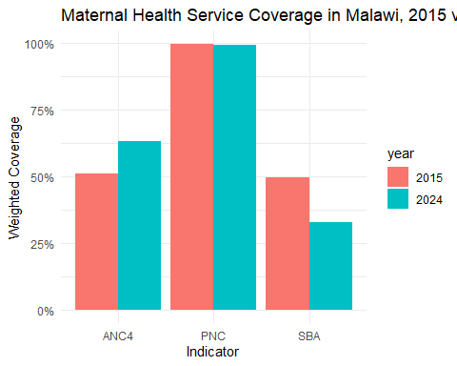

This pattern suggests a disconnect in the maternal care continuum: women may be increasingly reached through antenatal care, but this does not necessarily translate into skilled support at delivery. Because skilled birth attendance is strongly linked to prevention and management of childbirth complications, the decline in SBA is one of the most important findings of the project.
Equity and Disparities
Equity analysis showed that maternal health service utilization remains uneven across socioeconomic groups. ANC4+ coverage improved across wealth groups but remained higher among wealthier women. Skilled birth attendance declined across wealth groups, with poorer women continuing to face lower coverage than wealthier women. Education was also associated with service utilization, with women who had higher education generally showing better maternal health coverage. Urban areas had higher coverage than rural areas, confirming persistent geographic and access-related disparities.
Figure 2

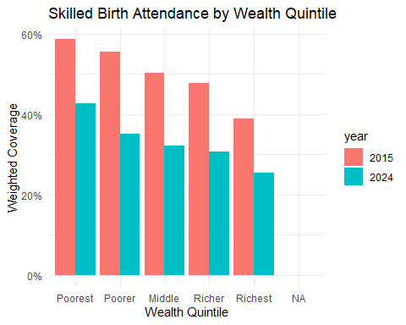
These findings indicate that improvements in maternal health coverage are not evenly distributed. Wealth, education, and residence remain important structural factors shaping whether women receive essential maternal health services.
Predictive Modeling
Predictive modeling was used to examine whether socioeconomic and demographic characteristics could predict non-utilization of key maternal health services. The initial SBA logistic regression model had high overall accuracy but failed to identify women who did not use SBA because of class imbalance. After applying class weighting, the balanced logistic regression model achieved approximately 68% accuracy and a ROC-AUC of 0.685. Recall for SBA non-use improved to 57%, although precision remained low at 5%.
A separate balanced logistic regression model for ANC4+ utilization achieved 53% accuracy and a ROC-AUC of 0.556, indicating weak predictive performance. This suggests that the available demographic and socioeconomic predictors alone are insufficient to fully explain ANC attendance patterns. Factors such as health facility access, perceived quality of care, transportation, household decision-making, and cultural norms may also be important but were not fully captured in the model.
Overall, the predictive models are useful for identifying broad patterns of vulnerability but should not be used for precise individual-level prediction.
Spatial Analysis
Spatial analysis revealed substantial district-level variation in maternal health coverage. A composite Maternal Health Coverage Index was created by averaging SBA, ANC4+, and PNC coverage at district level. The 2015 and 2024 maps showed geographic variation in coverage, while the change map highlighted districts that improved or declined over time.
Figure 3
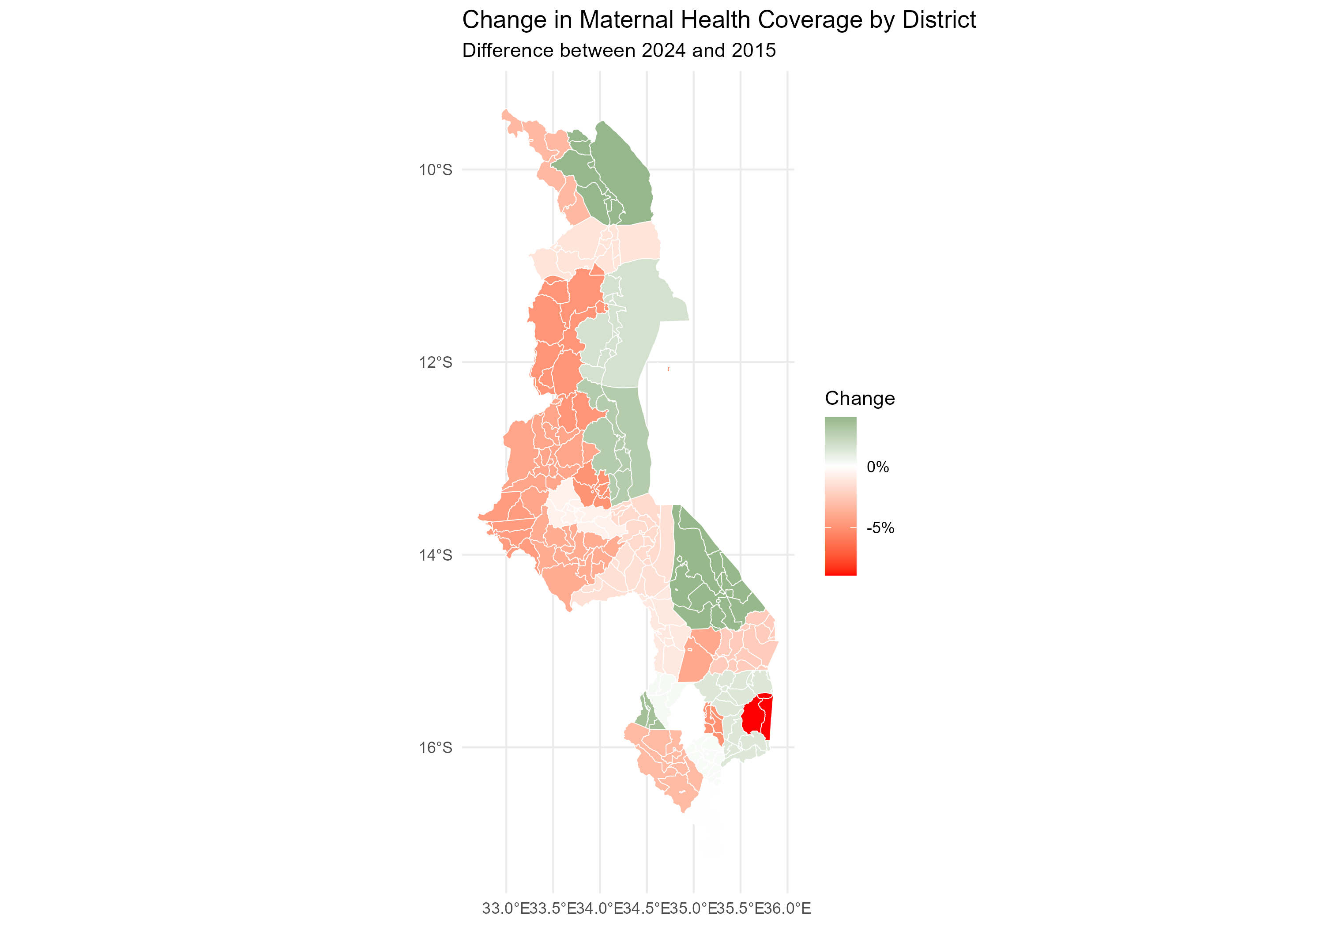

Several districts, particularly in northern and eastern Malawi, showed improvements. Other districts, especially in parts of central and southern Malawi, showed stagnation or decline. For example, Balaka declined from approximately 69.2% in 2015 to 65.2% in 2024, a decrease of about 4 percentage points. In the Power BI dashboard, Karonga was identified as one of the strongest improvers, while Kasungu showed one of the largest declines.
These findings show that national averages conceal important district-level disparities. Spatial visualization is therefore valuable for identifying priority districts for maternal health interventions.
Dashboard and Storytelling
The Power BI dashboard translated the analysis into a decision-support tool. The dashboard included an executive page summarizing national coverage, a spatial analysis page showing 2015, 2024, and change maps, an indicator comparison page comparing ANC4+, SBA, PNC, and the coverage index.
The dashboard reinforced the central message of the project: maternal health progress in Malawi is uneven. ANC4+ improved, PNC remained high, SBA declined, and district-level disparities persisted. By combining charts, maps, and model summaries, the dashboard provides an accessible way to communicate findings to policymakers and public health planners.
Final Interpretation
This project demonstrates that Malawi’s maternal health service coverage improved in some areas but weakened in others. The increase in ANC4+ coverage is encouraging because it indicates stronger engagement with antenatal services. However, the decline in skilled birth attendance is a major concern because it suggests that antenatal contact is not consistently translating into skilled delivery care.
The findings also show that maternal health progress is not equitable. Women in poorer households, rural areas, and lower education groups continue to face disadvantages. District-level spatial analysis further confirms that geographic disparities remain important. Some districts improved, while others experienced stagnation or decline.
Predictive modeling added value by showing that maternal health utilization patterns are associated with socioeconomic and demographic characteristics, but the models had only moderate to weak predictive performance. This reinforces the complexity of maternal health behavior and suggests that future models should include additional health systems, geographic, behavioral, and quality-of-care variables.
Overall, the project confirms that maternal health planning in Malawi should not rely only on national averages. More targeted, district-level, and equity-focused approaches are needed.
Recommendations
First, Malawi should prioritize reversing the decline in skilled birth attendance. This should include strengthening facility delivery services, improving referral systems, addressing transportation barriers, and ensuring that women who attend ANC are effectively linked to safe delivery care.
Second, maternal health programs should target districts with declining or stagnant coverage. Spatial analysis should be used to guide resource allocation, outreach planning, workforce deployment, and district-level monitoring.
Third, equity-focused interventions should prioritize rural women, poorer households, and women with lower educational attainment. Strategies may include community health worker follow-up, transport support, birth preparedness planning, and targeted health education.
Fourth, predictive modeling should be strengthened by incorporating additional variables such as distance to facility, quality of care, health worker availability, facility readiness, household decision-making, and community norms.
Fifth, dashboards and spatial visualization should be used as routine planning tools. Power BI or similar platforms can help decision-makers quickly identify where progress is occurring, where gaps persist, and which districts require priority support.
Finally, future research should examine why improved ANC attendance is not translating into improved skilled birth attendance. Qualitative or mixed-methods research could help explain behavioral, social, and health-system barriers behind this gap.
Limitations and Next Steps
This project has several limitations. DHS data are cross-sectional and cannot establish causality. Maternal mortality data from WDI are national-level estimates and cannot explain subnational variation. DHS GPS and administrative boundary data required additional harmonization, and district-level estimates may be affected by sample size differences. Some indicators also had missing values, particularly ANC and PNC variables.
The predictive models were limited by the available predictors. Although balanced logistic regression improved identification of SBA non-use, low precision shows that additional explanatory variables are needed. Future work should explore random forest, gradient boosting, or other machine learning methods, while also improving model interpretability.
Next steps include refining the Power BI dashboard, adding an equity-specific dataset to strengthen subgroup analysis, improving predictive modeling with additional variables, and preparing a shorter public-facing policy brief based on the project findings.
Acknowledgments
I would like to express my sincere appreciation to the many people who supported me throughout this capstone project and my broader data science learning journey.
I am deeply grateful to Professor Rachel Saidi, Data Science Program Director at Montgomery College, and Professor Lori A. Perine, Associate Professor at Montgomery College, for their guidance, encouragement, and instruction throughout the DATA 205 capstone process. Their support helped me strengthen my analytical thinking, improve my technical skills, and bring this project to completion.
I also extend my sincere thanks to Asad Azhar, Data Scientist at Peloria Insights, for his valuable support and insights related to data science practice and applied analytics. I am grateful to Madeleine Short Fabic, Public Health Leader and Demographer at ICF, for her encouragement and guidance for me to access as well as her public health perspective, which helped strengthen the relevance of this work. My appreciation also goes to Dr. John Borrazzo, Global Health and Development Analyst, Advocate, and Policy Advisor, for connecting me with Madeleine and ICF.
I would also like to thank Michael Iapalucci, Director at Fiber Locator, and Melissa Mostrom, Manager of Data Acquisition at Fiber Locator, for their support connected to my internship experience and for contributing to my professional growth in data-related work.
Finally, I am grateful to everyone who offered advice, feedback, encouragement, and practical support along the way. This project reflects not only my own effort, but also the generosity, mentorship, and guidance of people who helped me learn, persist, and grow throughout this capstone journey.
AI Use Disclosure
Generative AI support through ChatGPT was used to assist with code troubleshooting, R-to-Power BI export guidance, spatial data integration, dashboard planning, interpretation drafting, and editing of written sections. AI assistance was used as a support tool only. Dataset selection, analytical decisions, interpretation of results, and final academic responsibility remain my own.
References
National Statistical Office (NSO) [Malawi] and ICF. (2017). Malawi Demographic and Health Survey 2015–16. Zomba, Malawi, and Rockville, Maryland, USA: NSO and ICF.
National Statistical Office (NSO) [Malawi] and ICF. (2025). Malawi Demographic and Health Survey 2024. Lilongwe, Malawi, and Rockville, Maryland, USA: NSO and ICF.
World Bank. (2024). World Development Indicators. World Bank Group.
GADM. (n.d.). Database of Global Administrative Areas: Malawi administrative boundaries.

